Congratulations on your new READER position with UC Merced!

BEFORE YOU BEGIN WORKING…

You MUST visit the HR Student Employment Services office to complete all required hiring documents. This is applicable even if you are obtaining a second job as there may be additional forms required for your new job.

We are located in SSB 231 and are available Monday-Friday, 8 am to 4 pm

One of these very important required hiring documents is a form called “I-9” (established under the Immigration Reform and Control act of 1986).

Form I-9 is used for verifying the identity and employment authorization of individuals hired for employment in the United States. All U.S. employers must ensure proper completion of Form I-9 for each individual they hire for employment in the United States. This includes citizens and noncitizens. Both employees and employers (or authorized representatives of the employer) must complete the form. On the form, an employee must attest to his or her employment authorization. The employee must also present his or her employer with acceptable documents evidencing identity and employment authorization. The employer must examine the employment eligibility and identity document(s) an employee presents to determine whether the document(s) reasonably appear to be genuine and to relate to the employee and record the document information on the Form I-9.

Acceptable documentation for form I-9 are:

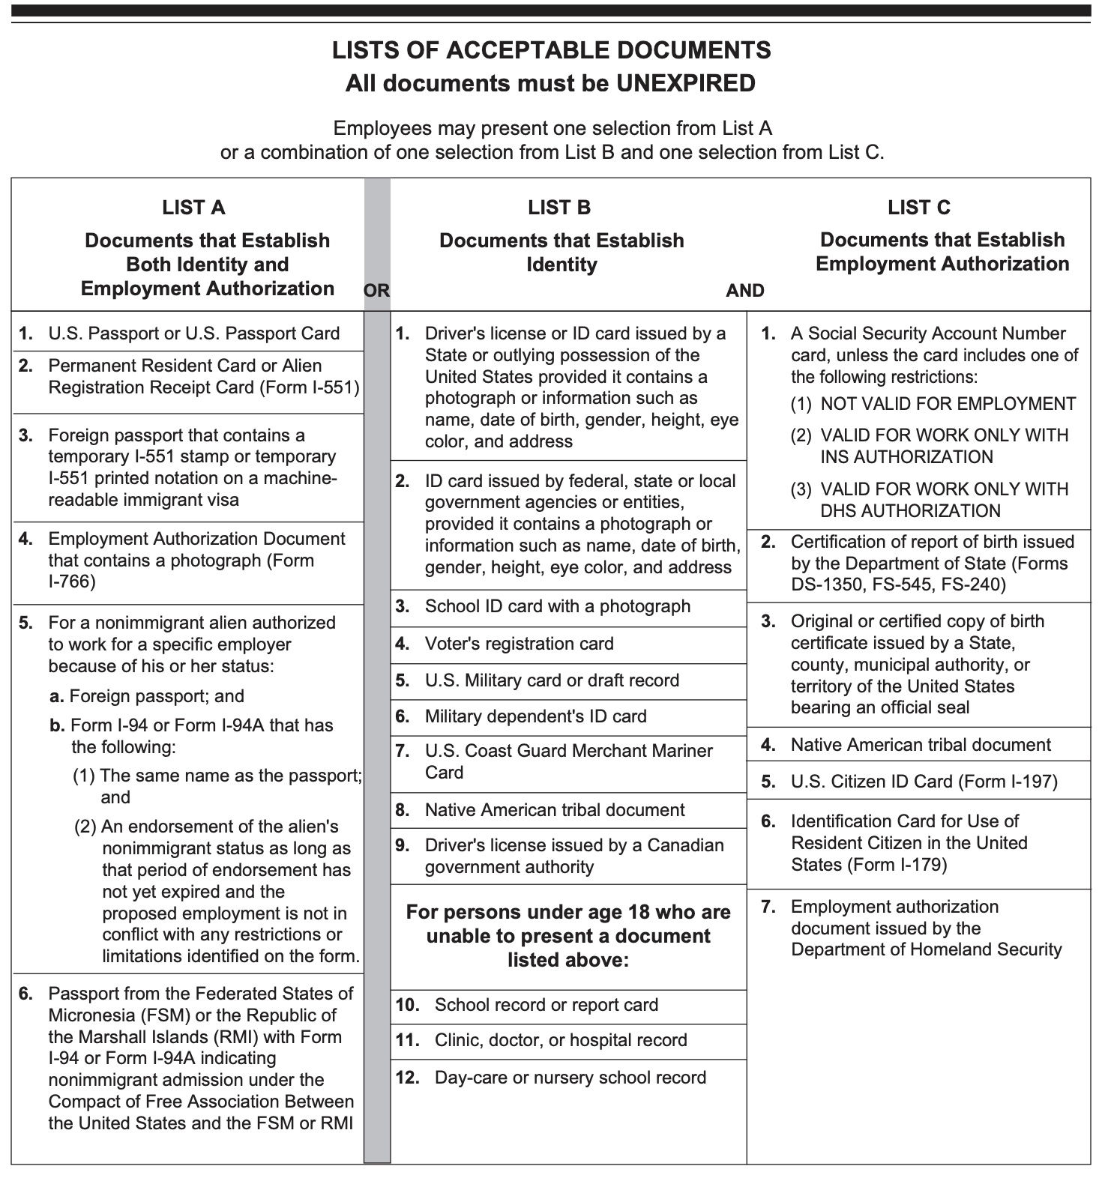
Contact Student Employment Services via email at studentemployment@ucmerced.edu or by phone at 209-631-8012

