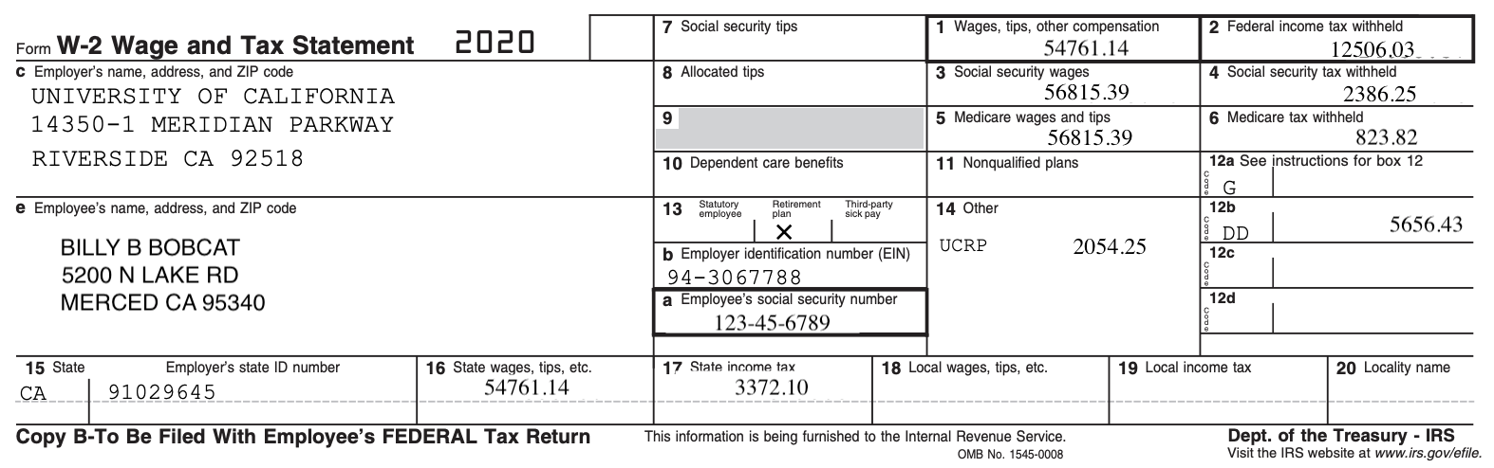
- Wages, Tips, Other Compensation: Your total federal taxable gross pay.
This can include:
  - Wages, bonuses, and other cash compensation (including prizes or awards)
  - Non-cash fringe benefits
  - Executive life insurance
  - Imputed income
  - Non-qualified moving expenses
  - Taxable employee business expense reimbursements
This does not include
  - 403(b) contributions
  - DCP contributions
  - Medical Contributions
  - Health Care (HCRA) and Dependent Care (DepCare) contributions
  - All other pre-tax contributions
- Federal Income Tax Withheld: The total amount of federal income tax that was withheld from your wages, tops, and other compensation.
- Social Security Wages: Total wages that are subject to social security tax ($128,400 for tax year 2018)
- Social Security Tax Withheld: The amount of social security tax withheld from all OASDI taxable wages. This amount should be equal to 6.2% of the wages listed in Box 3 up to the maximum allowed ($7960.80 for tax year 2018).
- Medicare Wages and Tips: The total wages, tips and other compensation that are subject to Medicare taxes. There is no limit on the amount of wages that are subject to Medicare taxes.
- Medicare Tax Withheld: The amount includes the 1.45% Medicare tax withheld on all Medicare wages, tips shown in Box 5, as well as the 0.9% Additional Medicare Tax on any of those Medicare wages and tips above
$200,000.

- Social Security Tips: This lists the tips you received that you reported to your employer.

- Allocated Tips: Shows tip income allocated to you by your employer.
- Advance EIC Payment: The total amount of any EIC (earned income credit) payments you have received during the year.
- Dependent Care Benefits: The total amount of any dependent care you had deducted for the year.
- Nonqualified Plan: Amounts distributed to you from nonqualified deferred compensation plans or non- government Section 457 pension plan. The amount in Box 11 is already included as taxable wages in Box 1.
- See Inst. For Box 12: The total amount of executive life insurance, 403(b) or 457(b) contributions, and excludable moving expenses.
  - 12a: Code C – Taxable cost of group-term life insurance over $50K
  - 12b: Code E – Election deferrals under 403(b) contribution
  - 12c: Code G – Election deferrals under 457(b) contribution
  - 12d: Code P – Excludable moving expenses
  - 12e: Code Y – Deferrals under a section 409A nonqualified deferred compensation plan
  - 12f: Code Z – Income under a section 409A nonqualified deferred compensation plan
  - 12g: Code DD – Cost of employer-paid health insurance (The amount reported with Code DD is not taxable)
- Retirement Plan: This box is checked if you are a member of the UC retirement plan.
- Other: This box is used by the University to report other information to you. This box may contain one or more of the following:
  - UCRP: University of California Retirement Plan
  - DCP-CAS: Defined Contribution Plan Casual
  - DCP-REG: Defined Contribution Plan Regular (included in Box 1)
  - Other Inc.: Imputed income, Travel Reimbursement, Taxable Relocation Expenses, Union Dues Withheld, Uniform Payment Deductions, Non-excludable Moving Expenses, Auto Allowance, Social Club Membership

Interest
  - Fringes
  - HFSA: Health Flexible Spending Account (FSA) unsubstantiated claims
  - FFCRA/CARES related pay
- State Code and Employer’s State I.D. Number: Usually CA for California and the California employer identification number for California. If you live and/or work outside of California and withholding was required for that state, the corresponding state code and identification number will be listed as well.
- State Wages, Tips, Etc.: The total state taxable gross pay you received.
- State Income Tax: The total state income taxes that were withheld from your compensation.
- Local Wages, Tips, Etc.: The total local taxable gross pay you received.
- Local Income Tax: The total local income tax withheld from your compensation.
- Locality: If you live and/or work outside of California and the locality that you reside in requires withholding, the locality name will be displayed.
References:
IRS - https://www.irs.gov/individuals/employees/tax-withholding CA State Franchise Tax Board -
https://www.ftb.ca.gov/individuals/index.shtml?WT.mc_id=Global_Individuals_Tab

